TITLE (TIMES NEW ROMAN, 14PT, BOLD, ALL CAPS, CENTERED)

Author’s Name and Surname¹, Author’s Name and Surname², and Author’s Name and Surname^{3,*} (10pt)
^{1,3}Green Chemistry and Sustainability Program, Department of Chemistry, Faculty of Science, Chulalongkorn University
²Organization information that the author is committed to
*Corresponding author, Email: xxx.y@chula.ac.th

ABSTRACT - Abstract should be written in 200 words and with 10 font size, Times New Roman, justified, single line spacing.

Keywords: Five words maximum (10pt; Times New Roman; separated with semi-colon)

1. INTRODUCTION (12pt, BOLD, ALL CAPS)

Extended abstracts should be written with Times New Roman, 10 font size, justified, and single line spacing. Page margins are formed regarding the A4 page size and are 0.7” wide from the sides. Extended abstract should not exceed 3 pages including images, tables, and references and pages should not be numbered.

2. METHODOLOGY (12pt, BOLD, ALL CAPS)

2.1. Materials (11pt, BOLD, ALL CAPS)

  - 2.2. Methods

  - 2.3. Subtitle

3. RESULTS AND DISCUSSION (12pt, BOLD, ALL CAPS)

  - 3.1. Subtitle

All of the tables and figures should be centered as shown as an example in Figure 1. Figure definitions should be placed under the figure. As for the tables, they should also be numbered (Table 1) and the table header should be placed at the top of the table. Table and figure headers should be written with upper case initial letters, bold and should be centered.

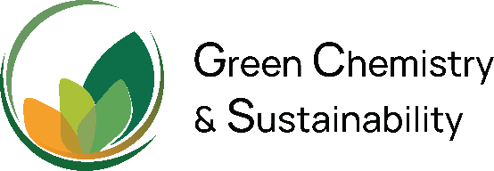

Figure 1. Logo of GCS

  - 3.2. Subtitle

Table 1. Table header
Sample number | Concentration (mg/L) | Absorbance
Standard #1 | 0.000 | 0.025
Standard #2 | 0.199 | 0.138
Standard #3 | 0.403 | 0.279
Standard #4 | 0.789 | 0.564

4. CONCLUSIONS (12pt, BOLD, ALL CAPS)

Please summarize your work stating your important findings as well as your future work.

ACKNOWLEDGMENT (12pt, BOLD, ALL CAPS)

Please acknowledge your research grant, organization, and scholarship here.

REFERENCES (12pt, BOLD, ALL CAPS)

Please use ACS citation style throughout.

Please submit your work in pdf file. Name the file with your full name.

